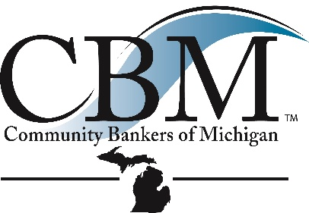
FOR IMMEDIATE RELEASE:
September 9, 2026
Contact: James North
Community Bankers of Michigan, CEO
517-336-4430
jamesnorth@cbofm.org

Community Bankers of Michigan Announces the 2026 Best of Community Banking Award

East Lansing, Mich.; September 9, 2026 - The Community Bankers of Michigan (CBM) has announced the Best of Community Banking award recipient to be recognized at the CBM Annual Convention & Expo, September 16-18, 2026, in Traverse City, Michigan. Joanne Rau, President and CEO, Chelsea State Bank, will be recognized for her positive impact and dedication to the community banking industry at the CBM banquet held Thursday evening at the convention.
The Best of Community Banking Award recognizes the contributions and success of Michigan community bankers. Special recognition is given to the community banker who has made significant contributions to their communities and the community banking industry.
James North, CBM President and CEO stated, “I am so pleased Joanne will be recognized as the recipient of the 2026 Best of Community Banking Award. She exemplifies the term “community banker” in so many ways, including a successful career in the banking industry and notable community engagement.”
Beginning as a credit analyst, Rau continued growing her banking experience through a strategic career path that prepared her to lead Chelsea State Bank and to positively impact the banking industry. She joined Chelsea State Bank in 2019 as its first female president, five months before the global pandemic impacted us all. The bank remained open throughout the shutdown to ensure employees and customers’ needs were met. She has led the team through establishing a remote access infrastructure for critical departments, guided the bank staff through a core conversion, branch expansion into a new market, all while experiencing significant growth.

Jessica Stubbs, Chelsea State Bank CFO shared, “In addition to her dedication towards her banking career, Joanne also an active supporter of the communities we serve. Her philanthropic efforts include serving on Chelsea’s School District scholarship committee, Board Chair of 5 Healthy Towns Foundation, serving on the Community Bankers of Michigan board, state and national advocacy on behalf of banking issues, and more. More impressively, her engagement with the Bank’s employees has created a culture of open communication and trust. From sitting down with every single employee on an annual basis gauging success and opportunities, to her open-door policy, both of which have led the Bank to be a Detroit Free Press Top Workplace for three consecutive years.”

About Community Bankers of Michigan
The Community Bankers of Michigan is a 250-member trade association serving community banks, and their financial services partners, throughout Michigan. With headquarters in East Lansing, Michigan, the Community Bankers of Michigan is dedicated exclusively to representing the interests of the community banking industry and its membership through effective advocacy, professional education programs, and high-quality products and services. For more information visit www.cbofm.org. One Mission. Community Banks.

###

