FOR IMMEDIATE RELEASE
Chelsea Education Foundation Invites Community to Rally for Students During Annual Rivalry Match Fundraiser
September 18, 2026 - CHELSEA, Mich. — As excitement builds for the annual Chelsea vs. Dexter Rivalry football game, the Chelsea Education Foundation (CEF) is inviting the community to support a tradition that extends far beyond the scoreboard.
Each year, the CEF Rivalry Match raises critical funds for teacher grants that bring innovative learning opportunities to students throughout the Chelsea School District. In fact, the Rivalry Match fundraiser provides approximately 80% of the funding for CEF's annual teacher grants, helping educators transform creative ideas into meaningful classroom experiences.
Last year, the Chelsea community demonstrated its commitment by surpassing the fundraising goal and falling just a little short of claiming victory over our rivals. While the Bulldogs are eager to reclaim the Rivalry trophy this season, Chelsea Education Foundation considers every investment in local classrooms and education a victory for students.
"One of the many things that makes this community so special is the way people come together to support a need," said Amy Forehand, President of the Chelsea Education Foundation. "The Education Foundations’ Rivalry Match is more than a football game and fundraiser; it's a bold statement from our community that we are committed to investing in our teachers and students. Every gift helps inspire learning, encourage innovation, and strengthen our schools."
Community members can support the campaign by donating before or during Rivalry Week. Every contribution, no matter the size, helps fund classroom grants that benefit students across the district.
To learn more or donate, visit www.chelseaeducationfoundation.org/rivalry.
About the Chelsea Education Foundation
The Chelsea Education Foundation is a nonprofit organization dedicated to enriching educational opportunities for students and teachers throughout the Chelsea School District. Since 1990, CEF has awarded more than 1,130 scholarships and funded over 815 teacher grants and educational programs, helping provide opportunities beyond what traditional school funding can support.
Photo Caption: A 2025 CEF Grant brought back the Monster Project and funded materials so CHS Art Students can bring Elementary students’ drawings to life.
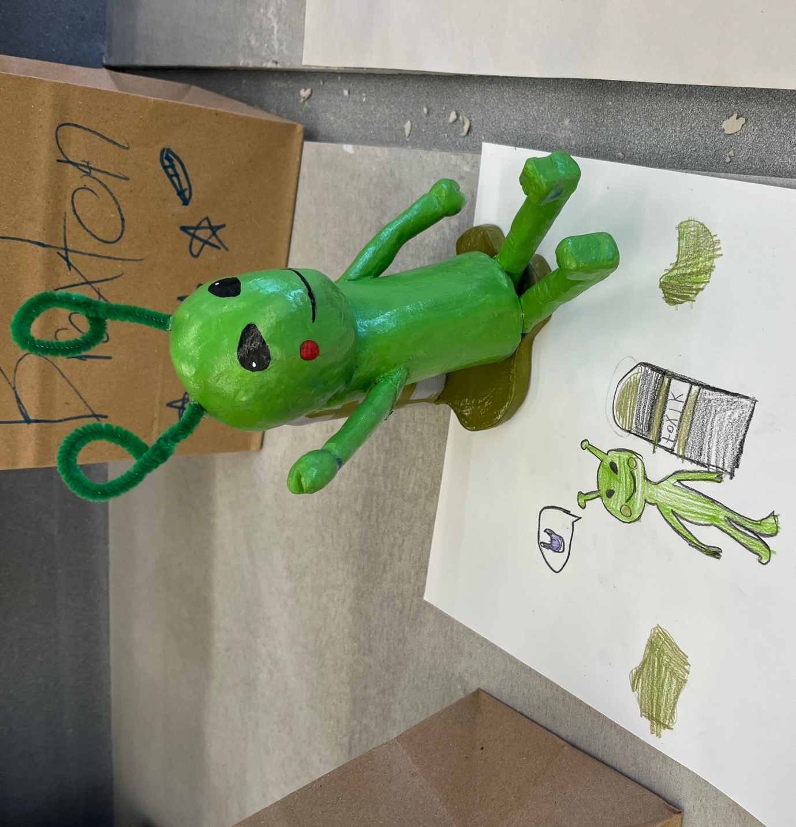
Media Contact
Amy Forehand
President, Chelsea Education Foundation
President@chelseaeducationfoundation.org
www.chelseaeducationfoundation.org

