Date: Monday, May 11, 2026
FOR IMMEDIATE RELEASE
Contact: Joanne Rau | President and CEO | 734-385-1122

CHELSEA STATE BANK & EMPLOYEES DONATE $2,616 TO IT ONLY TAKES 5, THROUGH BLUE JEANS FOR CHARITY

MONDAY MAY 11, 2026 | CHELSEA, MI – Chelsea State Bank and its employees donated $2,616 to It Only Takes 5, a local nonprofit organization last week. The dollars raised for this donation came from Chelsea State Bank (CSB) employees and a bank match as part of their ongoing Blue Jean for Charity Fund.

Over 10 years ago, Chelsea State Bank employees kicked off their Blue Jeans for Charity fund to raise money for local charities. Employees donate $3 per person weekly, allowing them to wear jeans to work on Fridays. Chelsea State Bank then matches the employee donations for the selected non-profit agency.

“It Only Takes 5 fills a need in the Chelsea and surrounding community,” said Joanne Rau, President and CEO, Chelsea State Bank. “Their purpose of collecting financial donations from members in the community, provides to those going through challenging times. They can respond to those needs quickly. Their unrestricted dollars have been the lifeline for families since this nonprofit came to light – and we are thankful for their volunteer efforts.”

About It Only Takes 5:
It Only Takes 5 is a small charity founded in Chelsea that encourages its members (currently over 1000) to give five dollars to meet the needs of local families encountering unforeseen difficulties. It Only Takes 5 pays out 100% of the funds raised.

About Chelsea State Bank
Chelsea State Bank is a full-service financial institution with offices in Chelsea, Dexter, and Jackson. The Bank was formed over 125 years ago by local business leaders to provide timely financial solutions to individuals, families, and businesses in the community. This tradition of community service continues today. For more information, please call 734.475.1355 or visit www.chelseastate.bank.
###

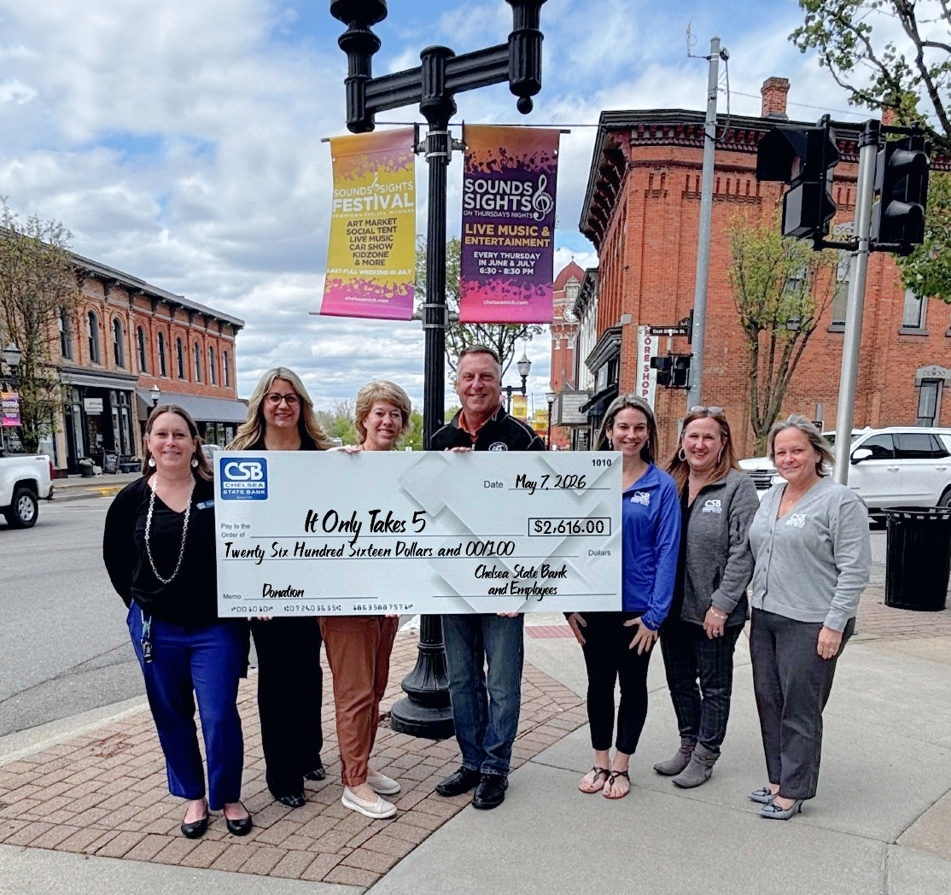
Pictured left to right: Carie Tillman, Nicole Bell, Sue Jacobs, Steve Jacobs, Emmalee Fischer, Jennifer Knope, and Angie Cavanaugh

