FOR IMMEDIATE RELEASE
May 27, 2026
Chelsea Education Foundation’s Art Party Event Raises Over $20,000 for Local Schools
The Chelsea Education Foundation (CEF) celebrated a major success at its recent Art Party: Bid, Create & Dance event, raising over $20,000—double the original fundraising goal. Held at Revel Run, the event brought together community members for an evening of art, music, and connection, all in support of creative programming and teacher grants within the Chelsea School District. Guests enjoyed a silent auction, interactive art experiences, dinner, drinks, and dancing. “We had so much support from artists and business owners in the area who generously helped sponsor the event or donated amazing art, gift cards, and items from their businesses for the silent auction,” said retired Beach Middle School Art Teacher, Kim Eder. “This kind of support speaks volumes about how much we value visual arts education in our community.”
As CEF concludes its 35th year, the success of The Art Party highlights the organization’s ongoing commitment to honoring its legacy while building the future. Funds raised will purchase pottery wheels and professional cameras for CHS students and contribute to sustained investment in teacher-led initiatives, classroom resources, and creative opportunities for students. The Chelsea Education Foundation also looks ahead to expanding its impact through continued community engagement and long-term funding efforts, including the growth of its endowment.
CEF extends its sincere thanks to the evening’s sponsors for helping make the event possible.
Gold Sponsors – John and Donna Daniels • Diane Kielszewski – Edward Jones • SBK Orthodontics
Art Advocate Sponsors – Roberts Paint and Body • Eder & Diver Insurance Agency • Rankin Audiology & Hearing • Revel Run • JDW & Associates
The Chelsea Education Foundation also thanks all attendees, donors, volunteers, artists, and community members who contributed to the evening’s success.
Those who were unable to attend but would still like to support the Chelsea Education Foundation and its mission can make a donation at ChelseaEducationFoundation.org.
Chelsea Education Foundation is a 501(c)(3) nonprofit organization that provides funding for a broad spectrum of educational activities benefiting the students of the Chelsea School District. Since 1990, $1.4 million in donations have been collected to support grants and scholarships throughout the District. Chelsea Education Foundation's mission is to enhance the District's educational experiences by financing projects beyond the District's resources and by providing scholarships to District graduates.

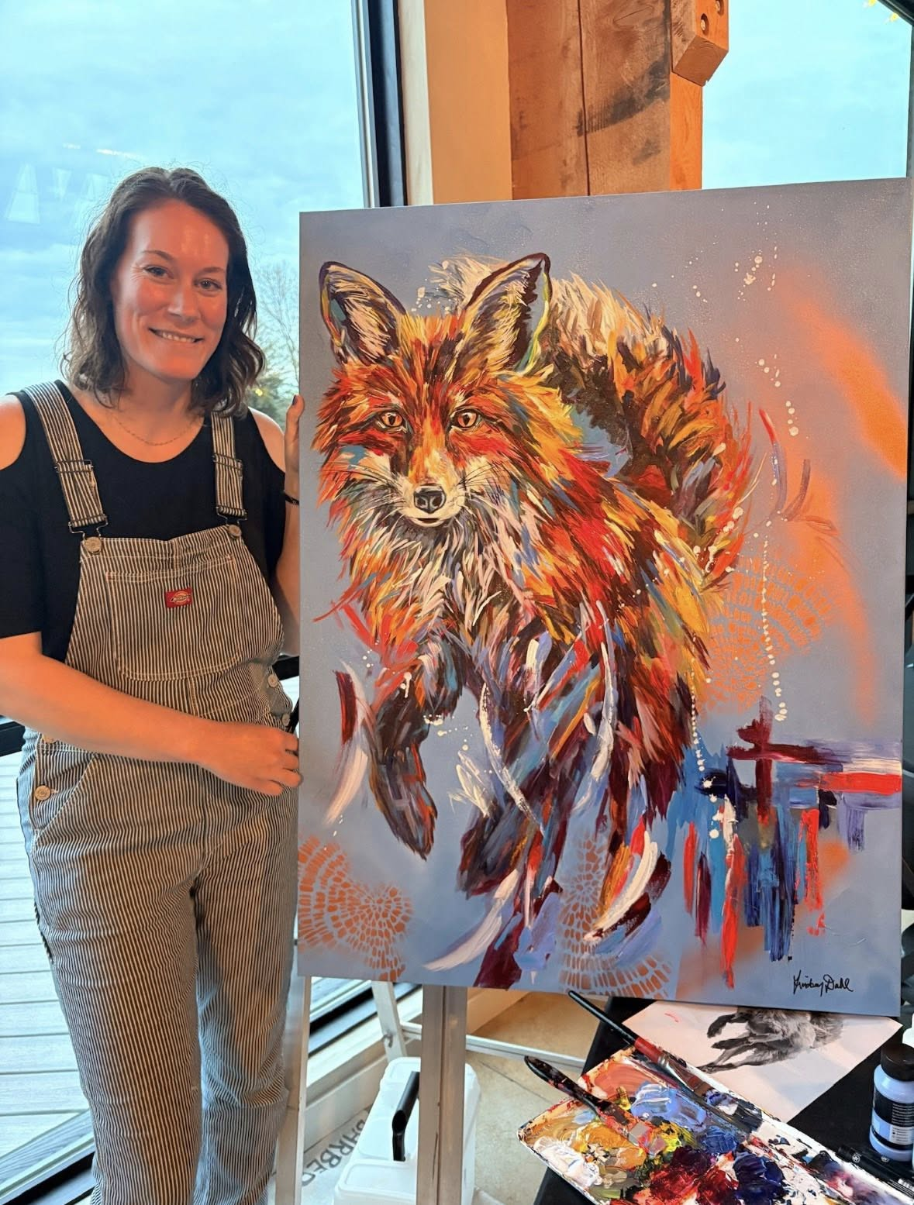
Local artist Lindsey Dahl’s live art painting was a silent-auction favorite.
CONTACT:
Chelsea Education Foundation
cefboard@chelseaeducationfoundation.org
president@chelseaeducationfoundation.org

